The Complete Test Suite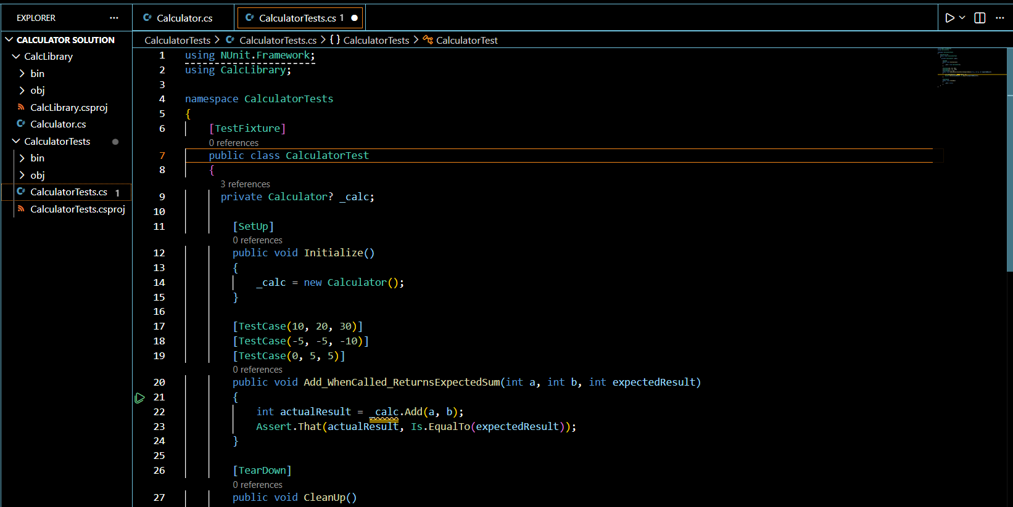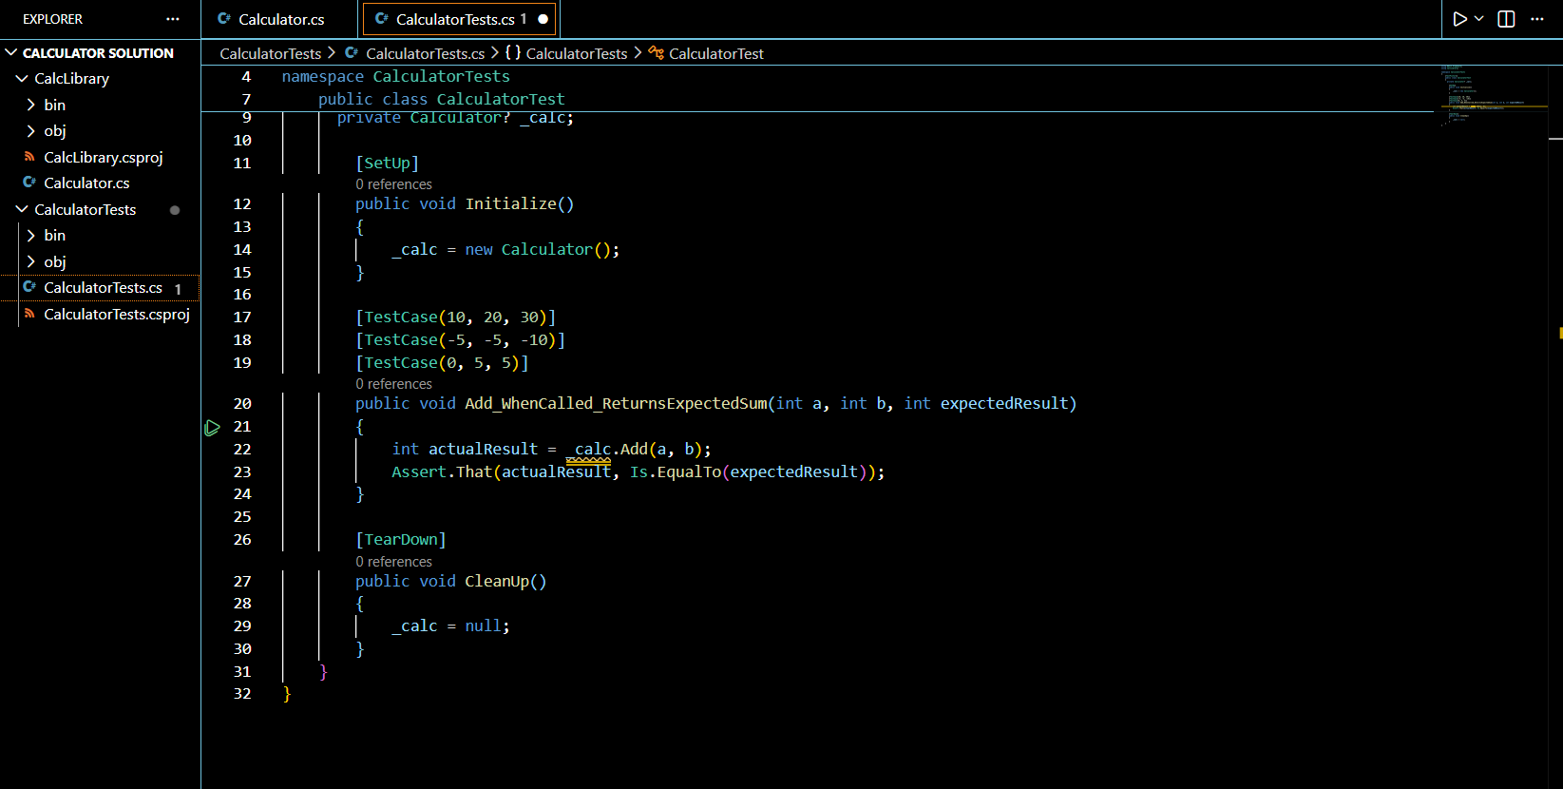

The Calculator Source Code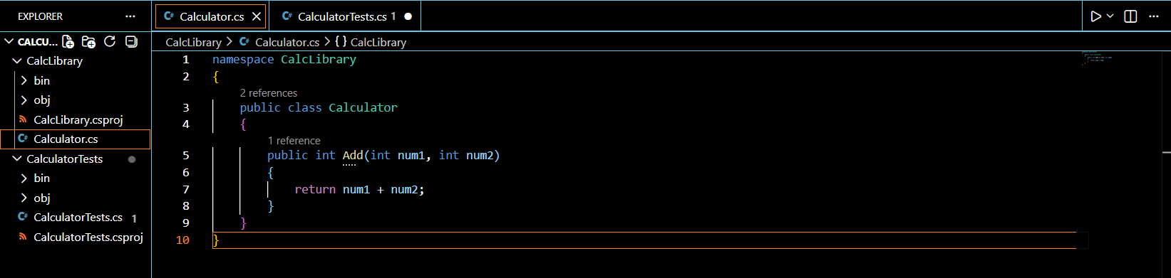

The Clean, Passing Terminal Output